1.Write a pig script to find the minimum temperature observed in a given weather station in a

particular year.

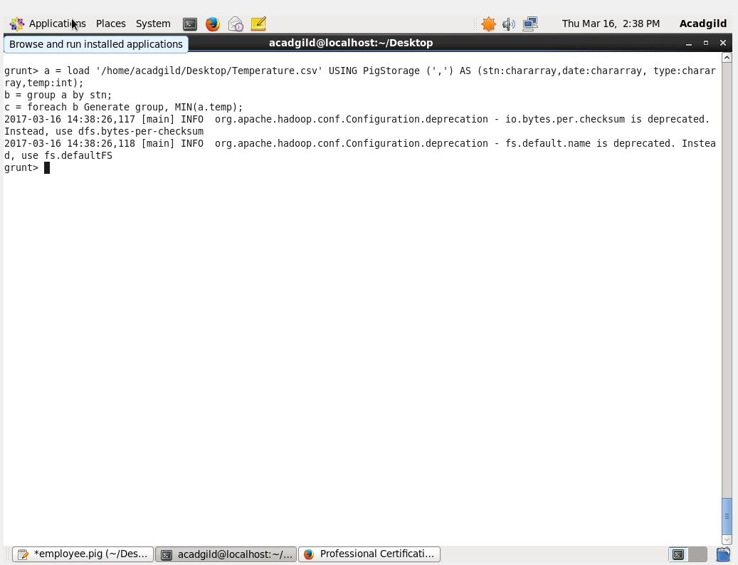

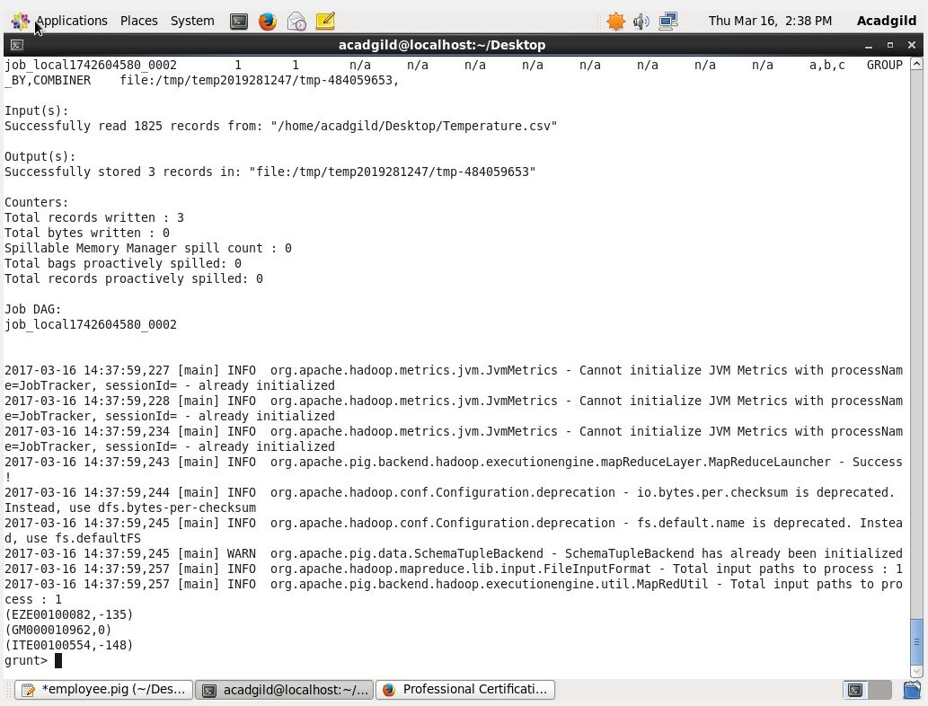

2. Write a pig script to find the maximum temperature observed in a given weather station in a

particular year.

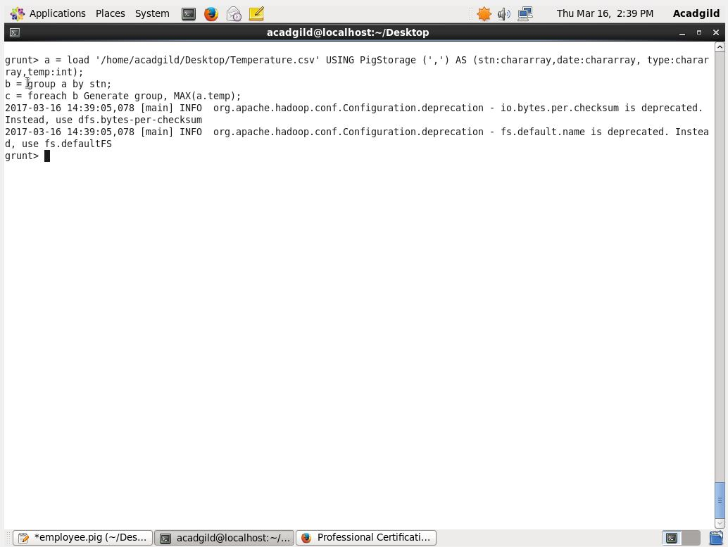

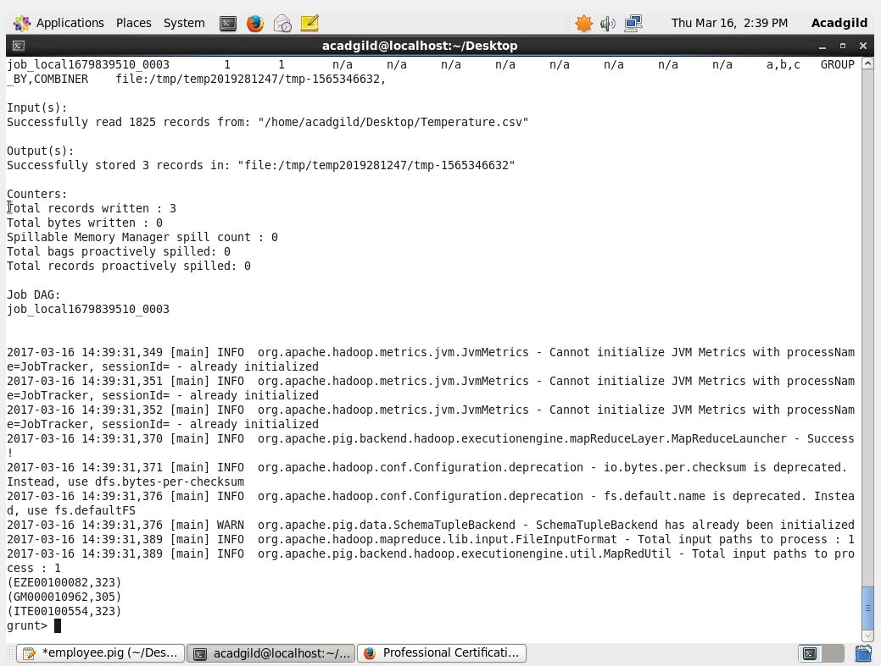

3. Write a pig script to find the number of readings given by each weather station according to the

dataset.

